Here Comes the Sun! Don’t Miss These Marketing Opportunities

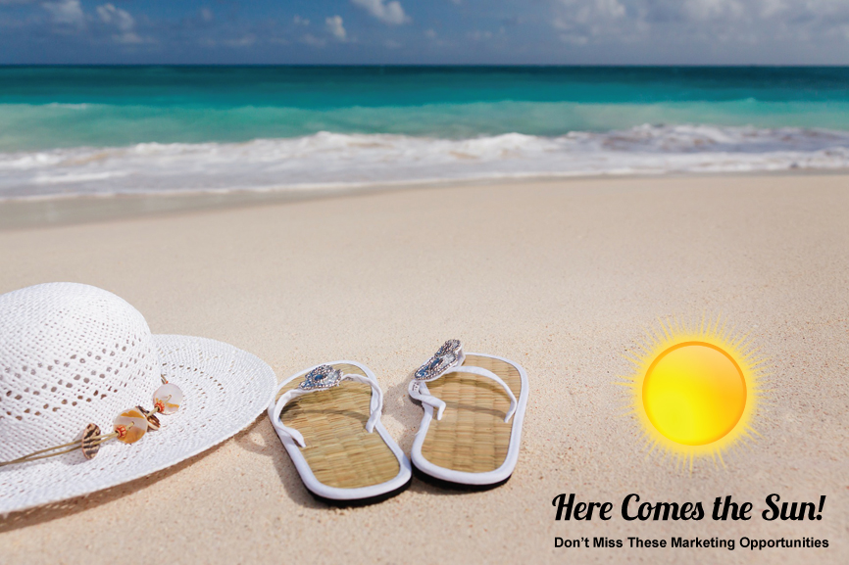

Britain is currently basking in record-breaking temperatures and it looks as though the heatwave is set to continue. On Sunday temperatures reached 30C (86F), making it hotter than Thailand and the hottest 18th June since records began.

Don’t miss out on summer marketing opportunities? Have you planned your campaigns? Make sure you add promotional products into the mix.

Why Promotional Products?

- Customers are less likely to throw away promotional products than leaflets and flyers
- Promotional items have the potential to increase your brand reach
- Promo gifts are a great way to say thank you and show your gratitude
- Promotional merchandise is extremely cost-effective, especially if you buy in volume, and offers a good ROI
- There are countless ways promotional products can be integrated into your marketing campaigns, ensuring you see the best return for your investment
- In a digital world physical products stand out
- Useful or everyday items will ensure repeated brand exposure, maximising your coverage
- Promo items help your brand ambassadors do the work for you and spread the message
- All our products can be fully customised with your brand colours, logo, artwork or message

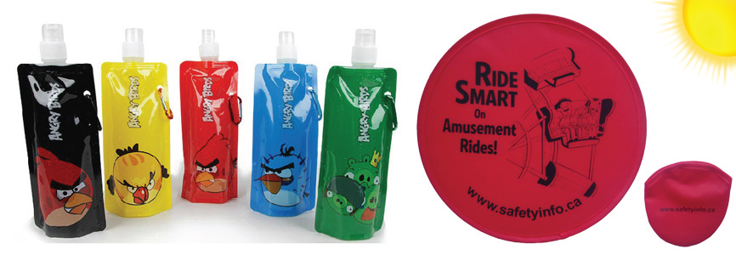

During the holiday season our custom Frisbees and promotional water bottles fly off the shelves. Both items can be fully customised with your choice of branding or artwork. And they can be folded away for easy storage. Our Frisbees even come in their own pouch which can also be customised at a small additional cost.

Make the most of the soaring temperatures with a fully integrated marketing campaign. Contact Carrie on 01524 230 300 for details of our summer promo items. And if you can’t find what you’re looking for, let us source it for you. We have worldwide contacts and can offer competitive pricing and a fast, efficient turnaround.

Title: Summer Marketing | Promotional Products for Soaring Temperatures
Description: Order your promotional products to coincide with holiday season. We offer custom Frisbees, water bottles and other great items.

